# CTS NURTURE 4.0_ JAVA FSE

#WEEK 3

# CREATING AND CONFIGURING A MAVEN PROJECT:

#MOOD MUSIC APP

# **MusicService.java – (in service)**

package com.ctsnurture.service;

import com.ctsnurture.model.MoodLibrary;

import org.springframework.beans.factory.annotation.Autowired;

import org.springframework.stereotype.Component;

*@Component*

public class MusicService {

private final MoodLibrary moodLibrary;

*@Autowired*

public MusicService(MoodLibrary moodLibrary) {

this.moodLibrary = moodLibrary;

}

public void recommend(String mood) {

System.***out***.println("Based on your mood (" + mood + "):");

System.***out***.println(moodLibrary.getPlaylist(mood));

}

}

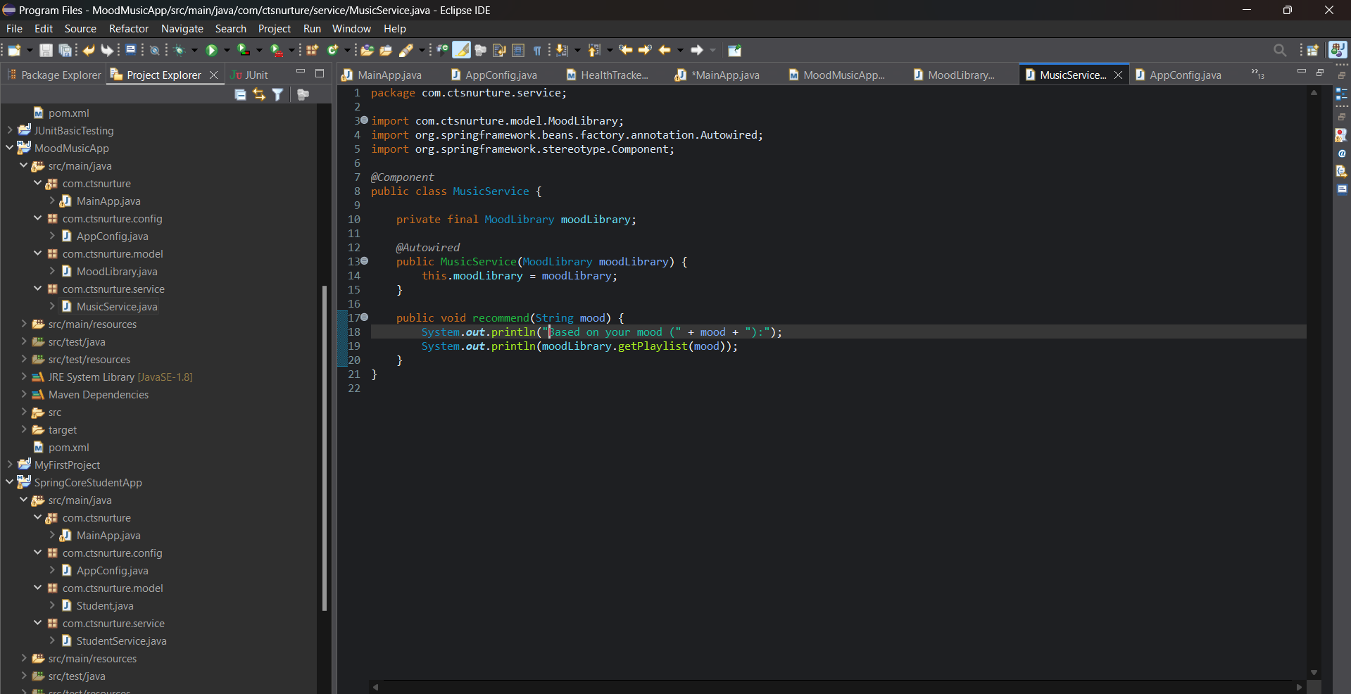

# MoodLibrary.java – (in model)

package com.ctsnurture.model;

import org.springframework.stereotype.Component;

import java.util.HashMap;

import java.util.Map;

*@Component*

public class MoodLibrary {

private Map<String, String> moodMap = new HashMap<>();

public MoodLibrary() {

moodMap.put("happy", " Pop Playlist: Happy Hits, Dance Now");

moodMap.put("sad", "Chill Playlist: Piano Moods, Soft Acoustic");

moodMap.put("angry", " Rock Playlist: Heavy Metal, Alt Rock");

moodMap.put("relaxed", " Calm Playlist: Lo-fi Beats, Jazz Vibes");

}

public String getPlaylist(String mood) {

return moodMap.getOrDefault(mood.toLowerCase(), " Mood not found. Try happy, sad, angry or relaxed.");

}

}

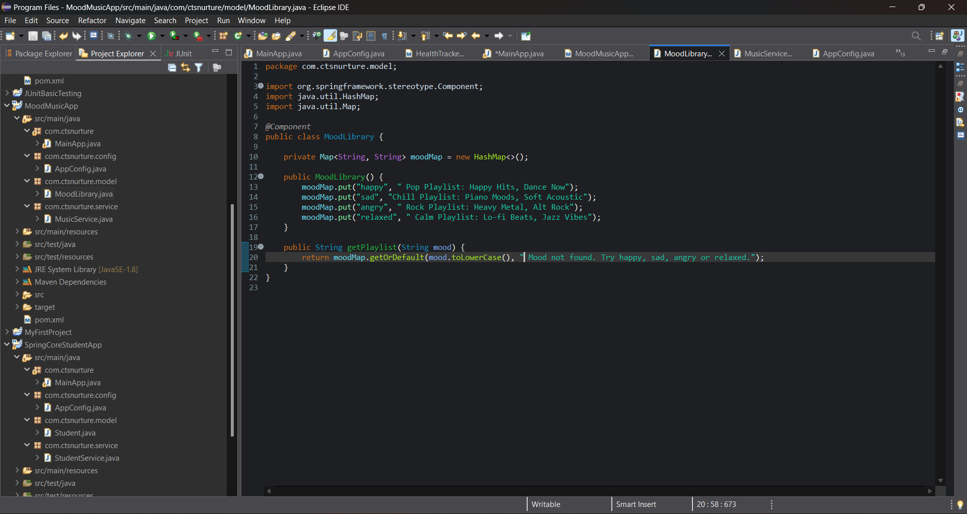

# AppConfig.java – (in config)

package com.ctsnurture.config;

import org.springframework.context.annotation.ComponentScan;

import org.springframework.context.annotation.Configuration;

*@Configuration*

*@ComponentScan*("com.ctsnurture")

public class AppConfig {

}

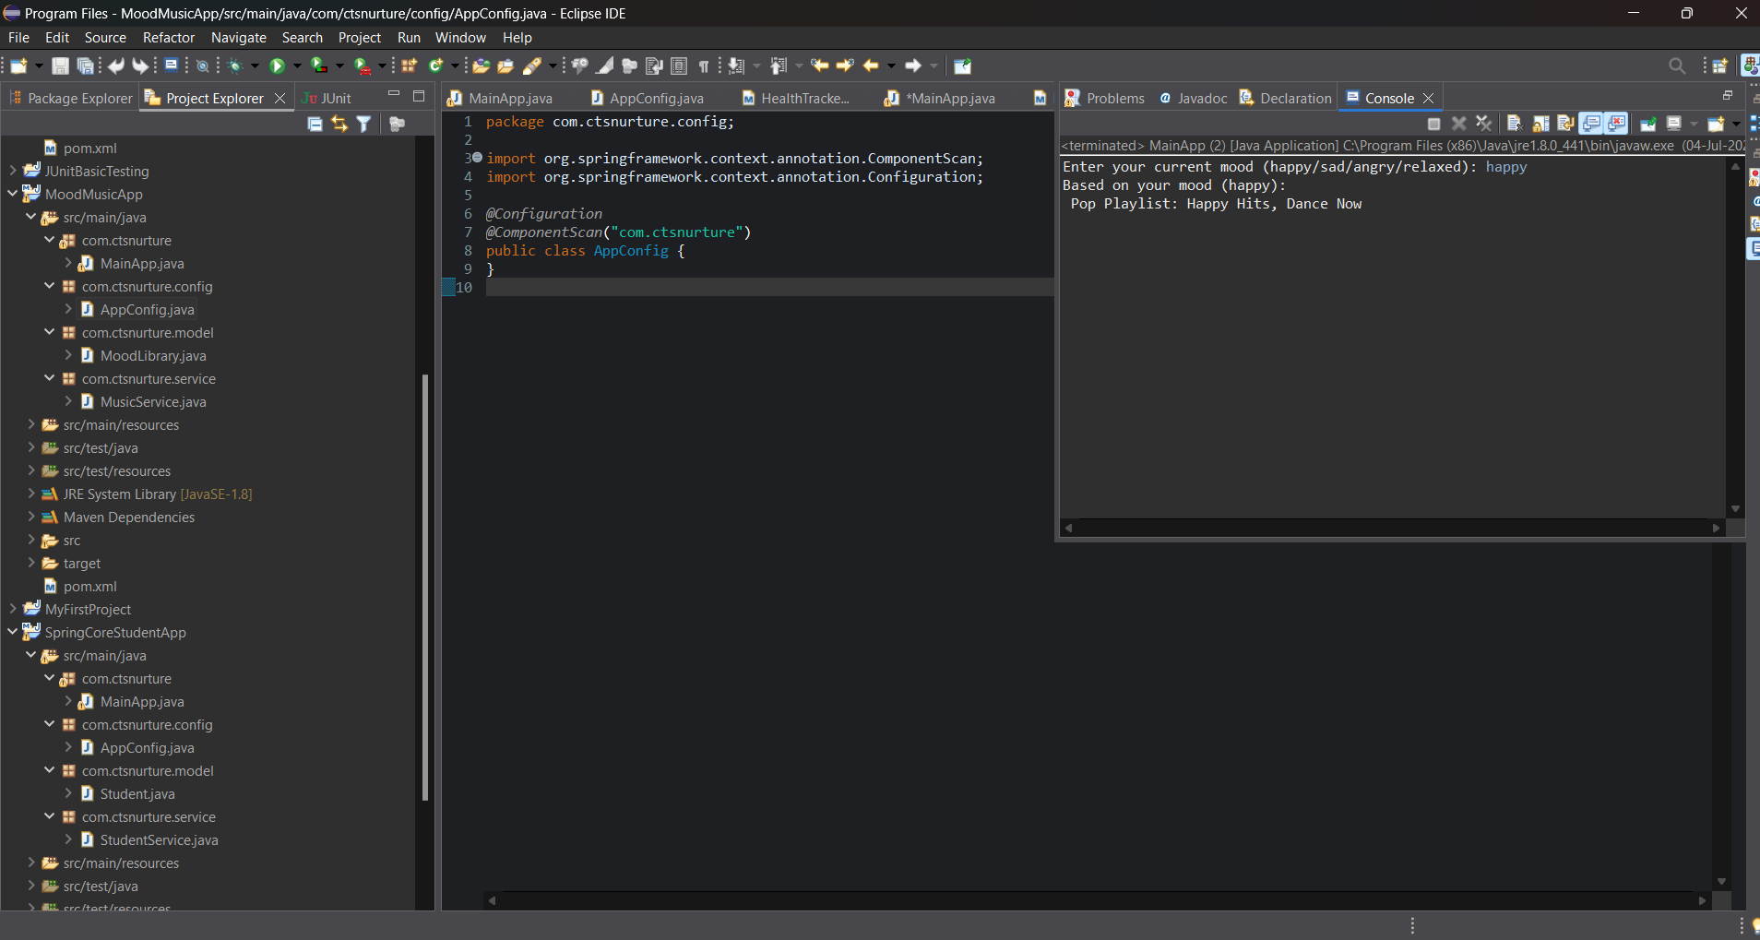

# MainApp.java – (in com.ctsnurture)

package com.ctsnurture;

import com.ctsnurture.config.AppConfig;

import com.ctsnurture.service.MusicService;

import org.springframework.context.ApplicationContext;

import org.springframework.context.annotation.AnnotationConfigApplicationContext;

import java.util.Scanner;

public class MainApp {

public static void main(String[] args) {

ApplicationContext context = new AnnotationConfigApplicationContext(AppConfig.class);

MusicService service = context.getBean(MusicService.class);

Scanner scanner = new Scanner(System.***in***);

System.***out***.print("Enter your current mood (happy/sad/angry/relaxed): ");

String mood = scanner.nextLine();

service.recommend(mood);

}

}

